OPOSSUM v0.4.0 released

The developers are happy to announce the release v0.3.0 of the optic design / simulation software OPOSSUM **(link auf Seite).** While the software is still in an early design / development phase and not really usable in daily work many new features have been added. Here are some of the highlights.

# Improved ray tracing capabilities

While the previous version contained only very basic support for ray tracing calculations (simple propagation and paraxial (ideal) lenses), we now added spherical lenses and flat surfaces. For this, two diffraction models (Sellmeier and Schott) have been added in order to model many optical glasses.

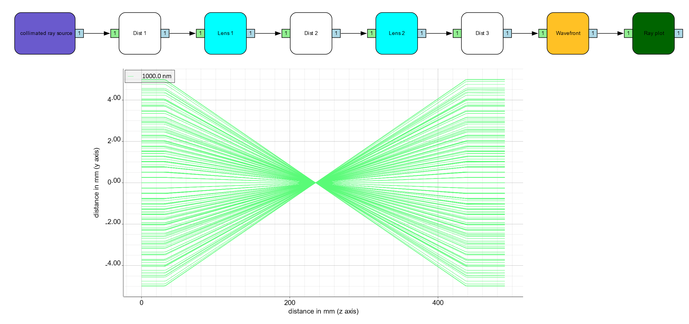

*Diagram and ray propagation plot of a simple Kepler telescope using spherical lenses.*

# Calculation of wavefront maps

The new wavefront map node shows the optical path difference at a given surface. Because of a potentially limited number of rays shot into a scene a phase surfaces makes use of triangulation and interpolation to produce smooth plots.

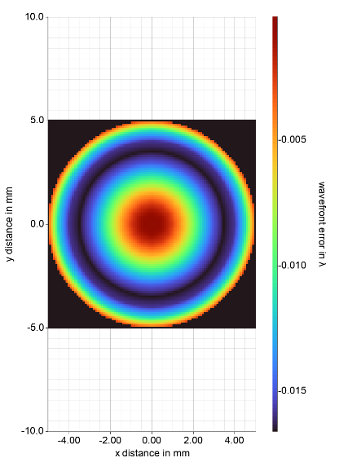

*Wavefront map of the above system. The spherical lenses also introduce spherical aberrations.*

# Calculation of fluence maps

A new node “fluence monitor” has been implemented, which visualizes the energy density at a given surface. This node takes the energy of an individual ray as well as the spatial density of the rays into account. While a simple binning procedure would give very poor results for a limited number of rays, we make use of an elaborate algorithm making use of Voronoi cells.

# First modelling of a real-life setup and benchmarking

The above-mentioned improvements and additions already allow for the simulation of some real-world scenarios. For this, we developed a model of the HHTS beam sensor at the PHELIX laser facility.

The HHT sensor (HHTS) is an end-of chain sensor which allows for measuring simultaneously 1054 nm and 527 nm laser beams (1 & 2 ω) with diameters of 150mm. The sensor demagnifies the beams down to camera-compatible sizes. The beams are then separated by a dichroic beam splitter into two distinct paths (1 & 2 ω). After further demagnification / imaging both rays hit nearfield and farfield cameras as well as energy meters.

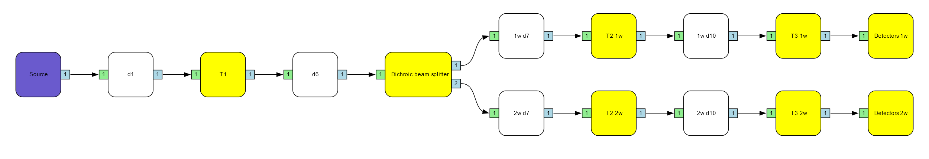

*Overview diagram of the PHELIX HHT sensor. This model makes use of group nodes (yellow) which contain further sub- nodes.*

A full simulation report for this system can be found (here)< als link auf PDF> Comparison with the ZEMAX simulation software showed an almost perfect agreement. Under certain conditions, a slight deviation (< 10 %) can be observed for wavefront calculations, which still has to be investigated.

# Further improvements

Besides above highlights, a lot of development work went in bug fixing and smaller improvements as well as a heavily extended test suite. Some statistics:

* 52 tickets closed
* > 300 repository commits
* > 500 unit tests
* > 90 % code coverage by unit tests
* > 18.000 lines of code

# Outlook

For the next release we will concentrate on a concise geometry model (global coordinate system, isometric transformations, etc.). This will possibly allow for the simulation of decentered and tilted optical elements.